Thesis Statement:

Thesis Research Questions:

Using Electromagnetic Induction (EMI) data, the following questions will be answered.

1. Between the 3 variations of the multi-target MIACE algorithm: greedy approach, thresholding approach, and clustering approach, is there a variation that is able to choose the underlying EMI target signatures? If so, which method performs the best considering ability and efficiency?
2. Using a clustering initialization approach to the multi-target MIACE algorithm, which of these three clustering methods (clustering1, clustering2, and clustering3) performs the best, considering ability and efficiency?
3. Are any of the three types of multi-target MIACE algorithms defined below better, considering ability and efficiency, than a single MIACE algorithm on individual target type classes and/or Global ACE using a generated Discrete Spectrum of Relaxation Frequencies (DSRF)?

Hypothesis:

A clustering approach will cluster all of the potential data points and learn a target signature from each of the clusters, therefor learning a variation of different target types and performing better than the other variations of ACE algorithms for EMI data.

The 3 multi target MIACE initialization methods being compared are a greedy objective value approach, a thresholding similarity approach, and finally the clustering approach.

The greedy objective value approach chooses the next target that maximizes the objective value, while considering the previously learned targets. To compute the objective value it computes the objective value for each learned target and a potential target, and then takes the maximum score across those for each data point.

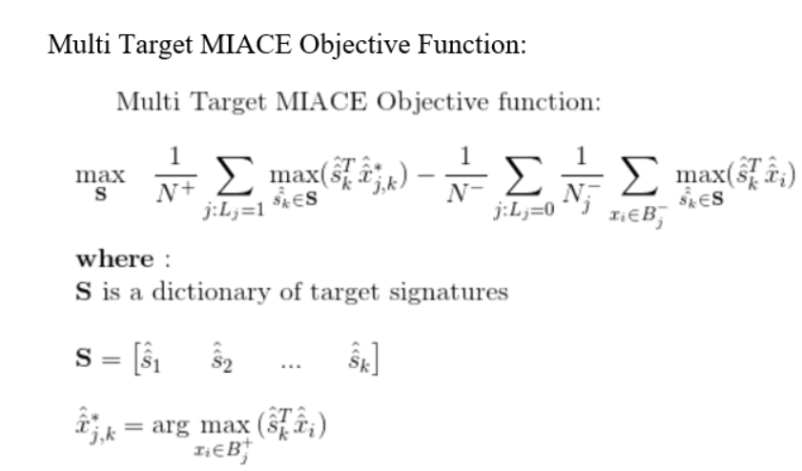

The thresholding approach will discard any potential target signatures that look like the target signatures already learned. It compares the ACE similarity statistic of the potential target to all previously learned targets and removes the potential target if its similarity is above some threshold.

\textup{Multi Target MIACE Objective function:}

\newline

\newline

\underset{\mathbf{S}}{\max} \quad \frac{1}{N^{+}} \sum_{j:L_{j} = 1} \underset{\hat{\hat{s_{k}}}\in \mathbf{S}}\max (\hat{\hat{s}}_{k}^{T} \hat{\hat{x}}_{j,k}^{*}) - \frac{1}{N^{-}} \sum_{j:L_{j} = 0} \frac{1}{N_{j}^{-}} \sum_{x_{i} \in B_{j}^{-}} \underset{\hat{\hat{s_{k}}}\in \mathbf{S}}\max (\hat{\hat{s}}_{k}^{T} \hat{\hat{x}}_{i})

\newline

\newline

\mathbf{where:}

\newline

\textup{\textbf{S} is a dictionary of target signatures}

\newline

\newline

\mathbf{S} =

\begin{bmatrix}

\hat{\hat{s}}_{1} && \hat{\hat{s}}_{2} && ... && \hat{\hat{s}}_{k}

\end{bmatrix}

\newline

\newline

\hat{\hat{x}}_{j,k}^{*} = \arg \underset{x_{i} \in B_{j}^{+}}{\max} (\hat{\hat{s}}_{k}^{T} \hat{\hat{x}}_{i})

Original MIACE Objective Function: 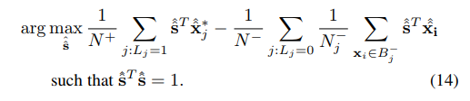

Multi Target MIACE Objective Function:

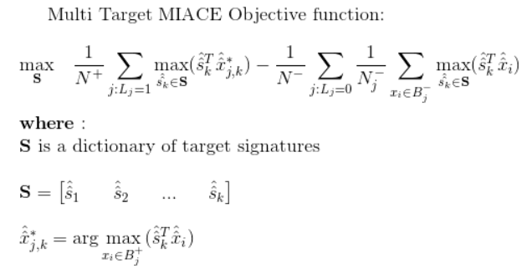



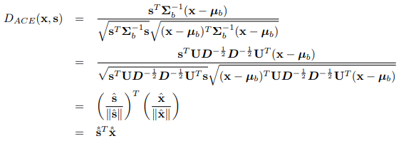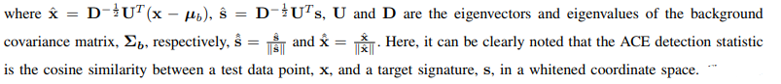

1. Chapter 1

**Topic:**

Provide an introduction to the thesis and the army data.

1. Introduction to thesis:
2. What research questions will be answered?
3. Introduction to the army data:
4. What is the goal for landmine detection?
5. How is the data formatted/provided?
   1. What is a lane?
   2. What is a grid?
6. What are the different types of landmines?
   1. High metal
   2. Low metal
7. How was the data collected?
   1. Collection site
   2. Date collected
8. Hypothesis:
   1. Provide hypothesis and formal thesis statement
9. Chapter 2

**Topic:**

Studying the 3 variations of multi target MIACE: greedy approach, thresholding approach, clustering approach.

**Research Questions to be answered:**

Between the 3 variations of the multi-target MIACE algorithm: greedy approach, thresholding approach, and clustering approach, is there a variation that is able to choose the underlying EMI target signatures? If so, which method performs the best considering ability and efficiency?

1. Background Literature Review:
2. MIACE
3. Proposed Algorithms Explanations:
4. Multi target MIACE Greedy Approach
5. Multi target MIACE Thresholding Approach
6. Multi target MIACE Clustering Approach
7. Experiments:

Ability:

1. ROC curves on High metal
2. ROC curves on Low metal

Efficiency:

1. Run time comparison
2. Space comparison
3. Data awareness comparison (How much do you need to know about the different classes within the data before running the algorithms)
4. Conclusions:
5. Chapter 3

**Topic:**

Studying what clustering approach for multi-target MIACE is the best out of three different approaches.

**Research Question to be answered:**

Using a clustering initialization approach to the multi-target MIACE algorithm, which of these three clustering methods (clustering1, clustering2, and clustering3) performs the best, considering ability and efficiency?

1. Background Literature Review:
2. Clustering for dictionary learning
3. Clustering Method 1
4. Clustering Method 2
5. Clustering Method 3
6. Proposed Algorithms Explanations:
7. Clustering Method 1
8. Clustering Method 2
9. Clustering Method 3
10. Experiments:

Ability:

1. Confusion matrix
2. ?

Efficiency:

1. Run time comparison
2. Space comparison
3. Data awareness comparison (How much do you need to know about the different classes within the data before running the algorithms)
4. Conclusions:
5. Chapter 4

**Topic:**

Studying if any of the 3 variations of multi target MIACE are better than Global ACE and MIACE on individual target classes, considering ability and efficiency than.

**Research Question to be answered:**

Are any of the three types of multi-target MIACE algorithms defined below better, considering ability and efficiency, than a single MIACE algorithm on individual target type classes and/or Global ACE using a generated Discrete Spectrum of Relaxation Frequencies (DSRF)?

1. Background Literature Review:
2. Global ACE
   1. Discrete Spectrum of Relaxation Frequencies (DSRF)
3. MIACE
4. Proposed Algorithms Explanations:
5. Global ACE
   1. Discrete Spectrum of Relaxation Frequencies (DSRF)
6. MIACE
7. Experiments:

Ability:

1. ROC curves on High metal
2. ROC curves on Low metal

Efficiency:

1. Run time comparison
2. Space comparison
3. Data awareness comparison (How much do you need to know about the different classes within the data before running the algorithms)
4. Conclusions: